WEEK – 2 MARKETING CAMPAIGN PERFORMANCE DASHBOARD REPORT
(NOTE: - Dashboard Image is at last page – 8)
INTRODUCTION:-
In this report, an analysis is provided for the designing and development of the Marketing Campaign Performance Dashboard using Power BI. The purpose of creating this dashboard is to turn raw marketing data into useful information to assist in making decisions.
The indicators of success highlighted by the dashboard include customer engagement, campaign efficiency, income, and ROI.

2. DATASET PROVIDED
The dataset includes customer – level and campaign-level attributes such as:-
- Customer demographics (Income, Education and Marital Status)
- Product spending (Wines, Fruits, Meat, Fish, Sweets, Gold)
- Campaign responses (AcceptedCmp1 to AcceptedCmp5)
- Marketing metrics (Impressions, Clicks, Conversions, Cost)

3. DATA CLEANING
Data is already handled in data cleaning process which includes remove duplicates, correctness of data type (CTR converted from varchar to decimal), handling null values COALESCE() , and Dt_customer is formatted properly for time series analysis.
4. KPI MEASURES (DAX EXPRESSIONS)
Key Performance Indicator(KPI’S):- KPI stands for “Key Performance Indicator”. It is a quantifiable measurement that tracks progress towards a specific business objective over a set period of time. KPI’s help businesses set goals(targets),monitor their achievement and identifies area for improvement.

First we understand what are DAX Measures?
DAX (Data Analysis Expressions) measures in power BI are dynamic calculations used to aggregate, filter and analyze data based on context. They can perform simpler calculations as well as complex calculations using user-defined formulas.
1. TOTAL CUSTOMERS:- Total Customers represents the total number of unique customers in the dataset.
Image – 1 (Total Customers)
2. TOTAL IMPRESSIONS: - Total Impressions indicates the number of times marketing content was displayed/seen.
Image – 2 (Total Impressions)
3. TOTAL CLICKS: - Total Clicks shows user engagement or how many times a user has clicked an ad.
Image – 3 (Total Clicks)
4. CTR (Click Through Rate):- CTR is the percentage of people who click on specific link, ad, or email after seeing it.
Image – 4 (CTR)
5. CPC (Cost Per Click):- Cost Per Click is a digital ad metric that measures how much an advertiser pays each time someone clicks on their online ad.
Image – 5 (CPC)
6. CONVERSION RATE:- measures the percentage of users who completed the desired action such as making a purchase or clicking a link.
Image – 6 (Conversion Rate)
7. TOTAL REVENUE:- Total Revenue is the total amount of money a business earns from selling goods or services during a specific period.
Image – 7 (Total Revenue)
8. ROI (Return on Investment):- ROI measures the profitability of the marketing campaigns.
Image – 8 (ROI)
TABLES CREATED FOR ANALYSIS:-
What are table measures?
Table measures are helper tables created using DAX to support visualization when data is wide format.
It helps us to convert the multiple product columns into one categorical structure.
1. PRODUCT TABLE:- Categories all the product such as Wines, Fruits, Meat, Fish, Sweets and Gold into one where data has different columns.
e.g. Wines | Fruits | Meat | Fish | Sweets | Gold
10 20 30 40 50 60
20 40 60 80 100 120
Then it combines all the different columns into one categorical structure here in image it is named as product therefore;
Product |
Wines
Fruits
Meat
Fish
Sweets
Gold

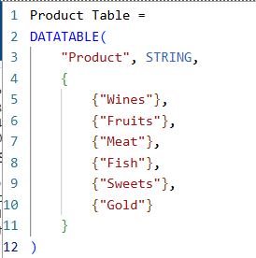
Image – 9 (Products Table)
2. CHANNEL TABLE: - Categories all the Channels such as Web, Store and Catalog into one where it is present in different columns.
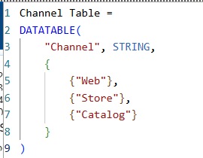
Image – 10 (Channel Table)
3. FUNNEL TABLE: - Categories all the stages such as Impressions, Clicks and Conversions into one column named Stage where it is present in different columns.
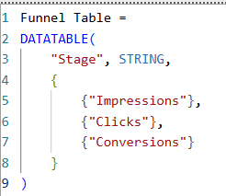
Image – 11 (Funnel Table)
4. CAMPAIGN TABLE: - Categories all the Campaign from (AcceptedCmp1 to AcceptedCmp5) into one column named Campaign.
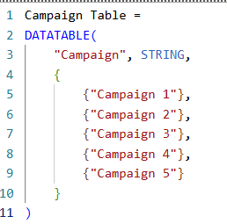
Image – 12 (campaign Table)
ADVANCED MEASURES: -
SELECTED VALUE: - Retrieves a single value chosen from a slicer or filter.
SWITCH FUNCTION: - It is like a CASE statement that evaluates a expression from a list of values it is like nested IF-ELSE.
1. PRODUCT REVENUE: - It performs the sum from a list of products where product will be selected by user.
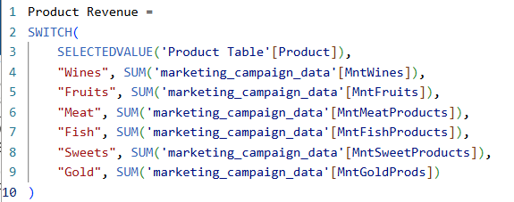
Image – 13 (Product Revenue)
2. CHANNEL PERFORMANCE: - It performs the sum from a list of channels where channel will be selected by user.
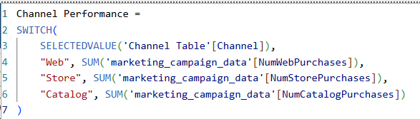
Image – 14 (Channel Performance)
3. FUNNEL VALUE: - It Performs the sum from a list of Funnel Table where stage will be selected by user only.
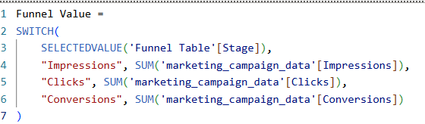
Image – 15 (Funnel Value)
4. CAMPAIGN REVENUE SELECTED: - It helps us to select the campaign from 1 to 5 from the user.
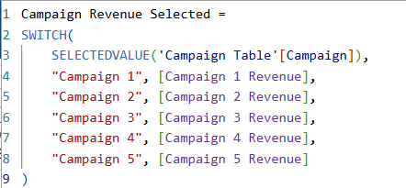
Image – 16 (Campaign Revenue)
VISUALIZATION:-
1. KPI Cards: - Displaying the Key metrics for quick overview of marketing campaign data.
2. Line Chart:- Showing the trend of clicks and conversions over date
3. Bar Chart(Revenue by Campaign):- Shows which Campaign performs the best.
4. Donut Chart (Product Revenue):- Shows contribution of each product
5. Funnel Chart:- Represents user journey and drop off Impressions, Clicks and Conversions.
6. Stacked Bar Chart(Channel Performance Chart):- Compares purchase behaviour across different channels.

SLICERS AND INTERACTIVITY WITH THEM:-
Slicers Used:-
1. Date (Dt_Customer)
2. Campaign
3. Customer Segmentation (Education and Marital Status)
This helps in Dynamic filtering of the data and improve user interaction.

CONCLUSION:- The dashboard successfully transforms raw marketing data into actionable insights. It enables stakeholders to evaluate campaign performance, understand customer behaviour and optimize marketing strategies.

FUTURE IMPROVEMENTS:-
1. We can Implement a deep research on customer segmentation to know there behaviour, purchasing patterns and performance.
2. weekly trend analysis:- We can do a real time analysis based on monthly campaign such that we know where are we are highest and where we can improve our scope where we lack behind.

DASHBOARD IMAGE
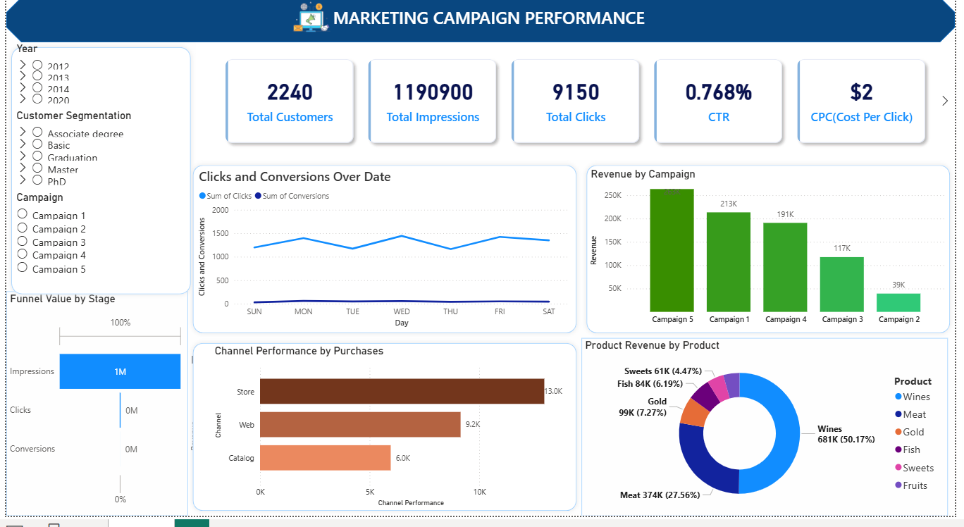
Image – 17 (Dashboard Image – 1)
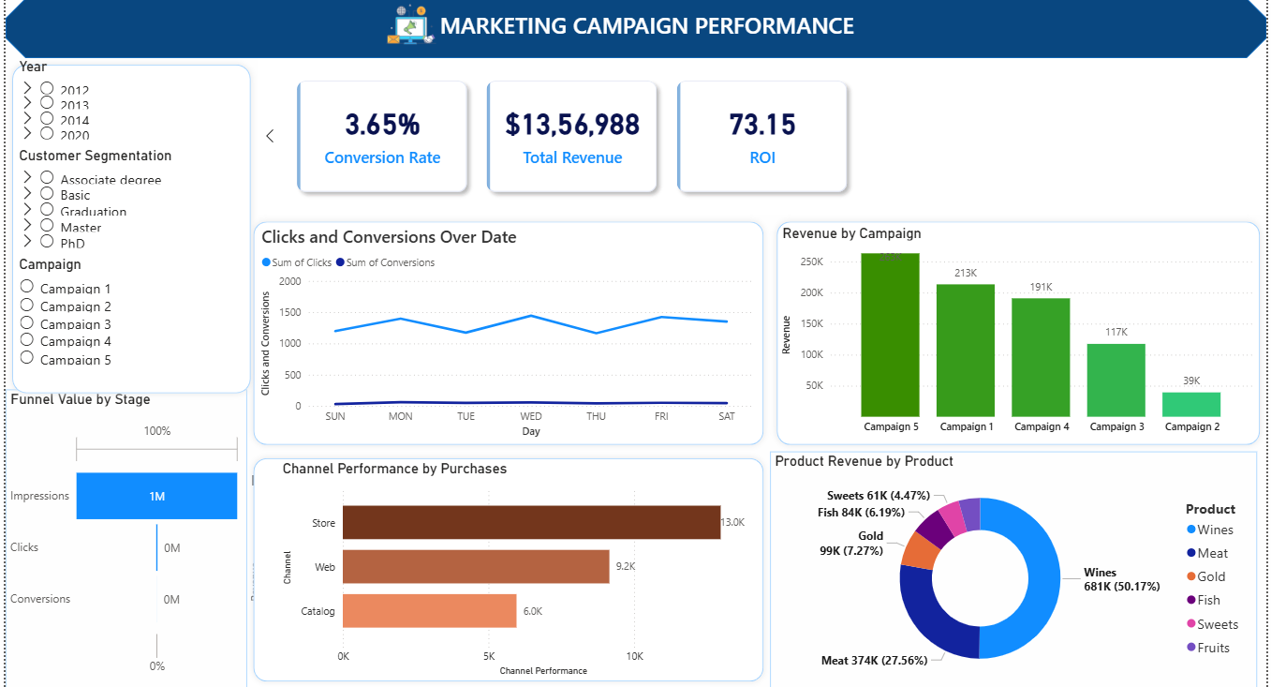
Image – 18 (Dashboard Image – 2)
There contains 3 more KPI’s Conversion Rate, Total Revenue and ROI

